Germán Martínez Cagigas
DAW
VirtualHost

INDEX

Sumario
INDEX 2
INTRODUCTION 3
EXERCISE 4
Our Website. 4
Website on folder. 4
VirtualHost 5
Text added. 6
System 32. 8
Hosts. 9
Virtual host. 9
Final though. 10
2.1. What was the most challenging part of this activity? How did you manage to solve it? 11
2.2. What are the main differences between a physical host and a virtual host in terms of resources and management, and how might this affect the performance and scalability of a web application? 12
CONCLUSION 13
BIBLIOGRAFIA 14

INTRODUCTION

Simulating a virtual host that will host our website.

EXERCISE

Our Website.

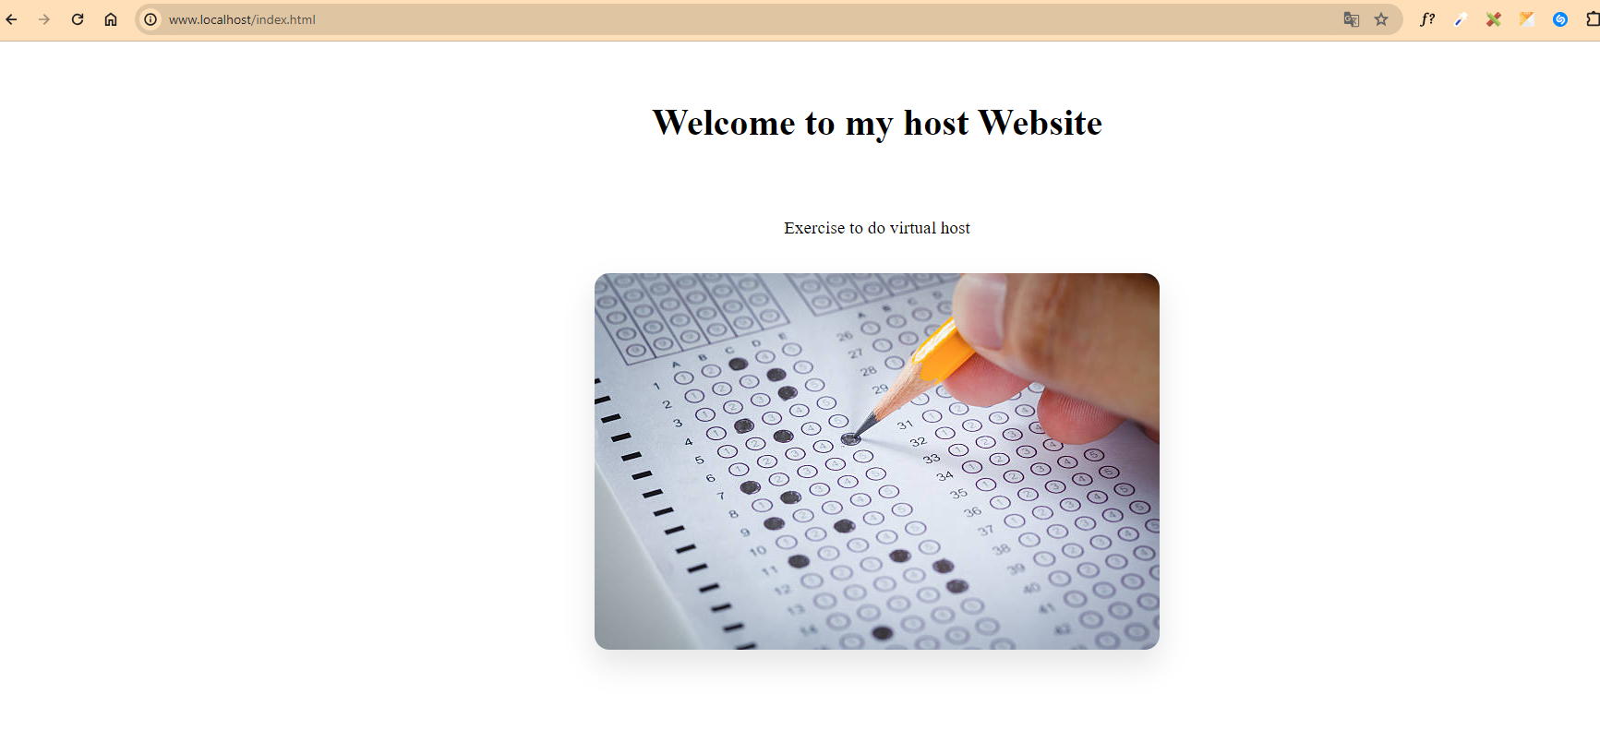Figure 1
As you can see on figure 1, its a simple Home page, without something relevant to explain, just h1, p, and a image with few css to center everything.

Website on folder.

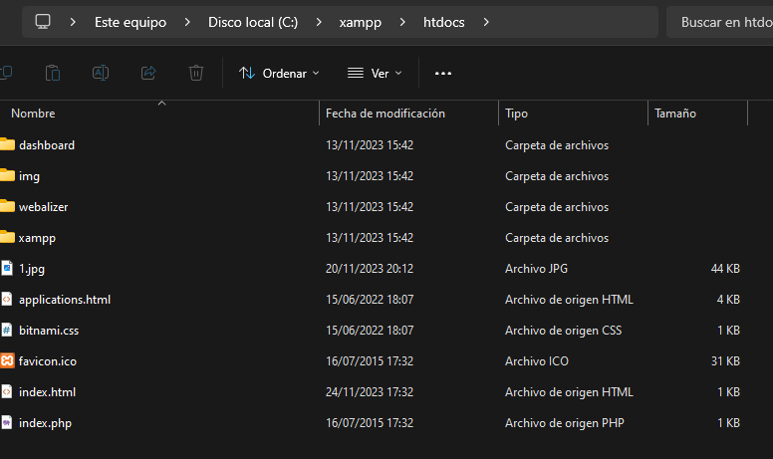Figure 2
In figure 2 you can check that the index.html is on htcdocs folder as always.

VirtualHost

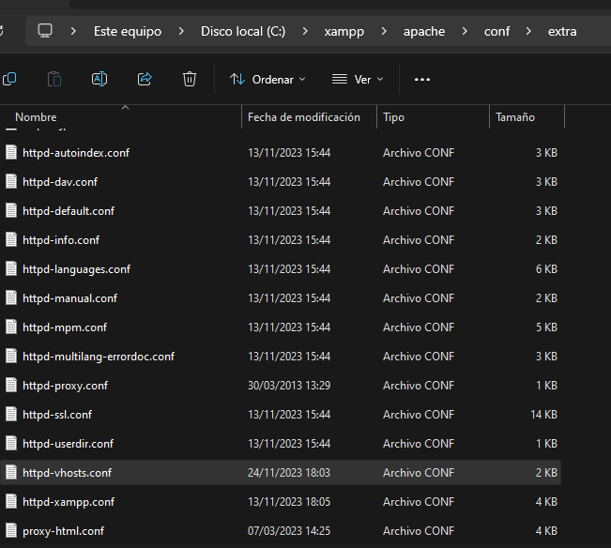Figure 3

In figure 3 mi going to dd our virtual host adding the related comand (text) to acomplish that objective on route: C:\xampp\apache\conf\extra\httpd-vhosts.conf

Text added.

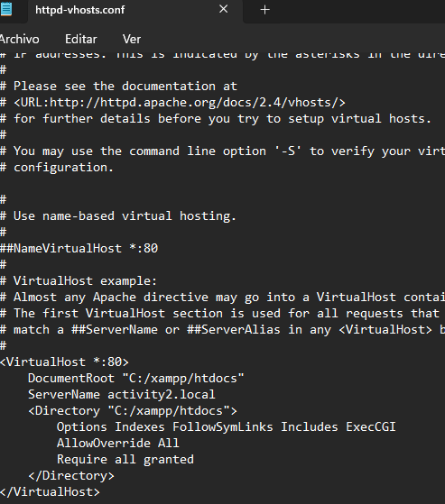Figure 4
On figure 4, i added only the route to the folder where i have the page, i had problems adding the full rout that would be add /index.html, that gave me an error, so i just used the route to the folder and then on the browser, we should add the page that we wanna visit in this case /index.html, if we had other hosted on that folder we could write /(other page). Extension and will work also.
Also here, we are calling this new virtual server as activity2.local, so now we need that our dns point to this domain, and say him that 127.0.0.1 is activity2.local so when we gonna writte activity2.local, windows will go to localhost (127.0.0.1) + the path: http://activity2.local/index.html will be http://127.0.0.1/index.html in this example.

System 32.

First of all, if we touch something here, it can crush our pc, so if it is possible better dont do it, but if you have to do something here, always as administrator.

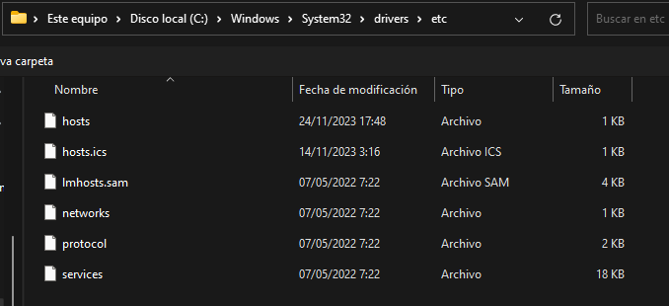Figure 5
First of all i executed, notes as an administrator and went to this path: C:\Windows\System32\drivers\etc, figure 5.

Hosts.
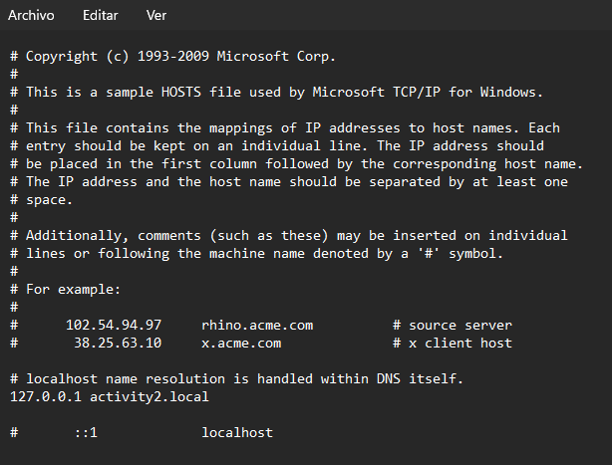Figure 6
Now in figure 6 we are mapping our virtual host to the localhost ip.
line: 127.0.0.1 activity2.local, save changes as an administrator.
So we only need now to restart our apache server.

Virtual host.

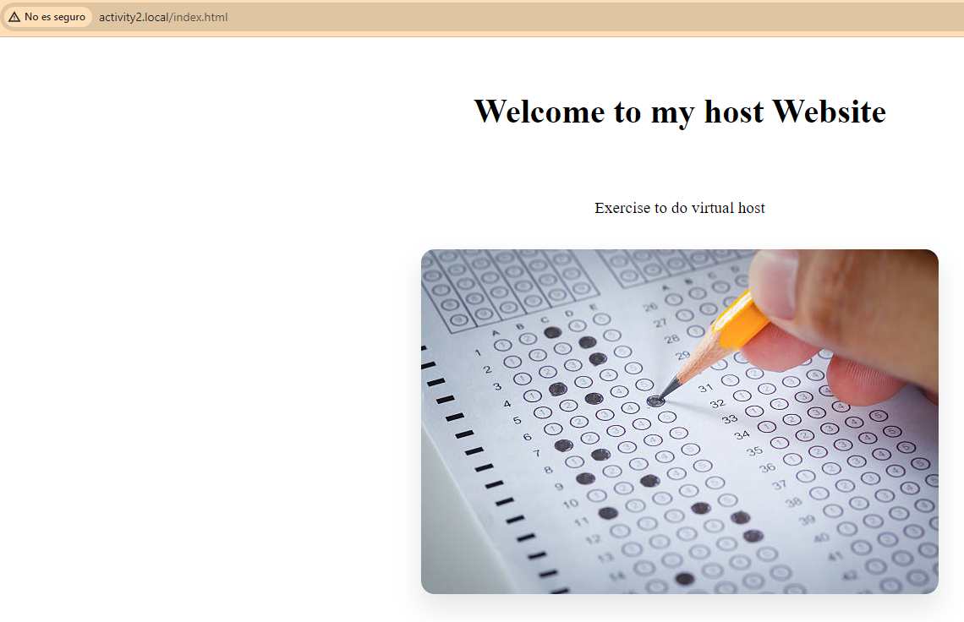Figure 7
And now if you followed the instructions you will be watching your page on the activity2.local route, as shows figure 7.

Final though.

I dont know if its important or not, but i also went to htcdocs folder and gave to my user total control because i had permission issues, maybe i was writing wrong something but mi just saying everything that i did.

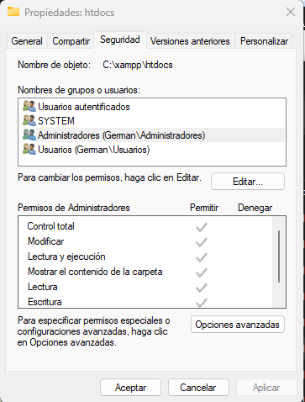

2.1. What was the most challenging part of this activity? How did you manage to solve it?

DocumentRoot "path to your website"
Directory "path to your website"
it was giving me problems add the full route, also i changed full permisions in htcdoc folder as i said, because path to your website i understand the full path, after change the permisions, and because i remember something of this from medium grade, i tried to write first other routes to see if the exercise is giving all resources or something is missing, so when i tried /htcdocs without add the full route and adding in the browser server + index.html, everything was working as expected.

2.2. What are the main differences between a physical host and a virtual host in terms of resources and management, and how might this affect the performance and scalability of a web application?

Scalability, nothing new, if you need more power, work faster or an improvement on your phy server, you will ned to buy pieces or a new one, in the other hand, you can just add other virtual host and end of the mistery more simple the scalability of virtual hosts.
But also the performance on virtual hosts should be worse, because more people is having access and the power of the phy server that host the virtual hosts, is sharing between them.

CONCLUSION
Anothe rsmall step through a simple to “deploy ” our virtual server, touching important things like dns, or where assign them.

BIBLIOGRAFIA

file:///C:/Users/abuse/Downloads/DU2.2%20Working%20with%20hosts.pdf

